Master Services Order Form
This Order form is part of and shall be governed by, the Kerv Linked Master Services Agreement and its schedules (together with this Order, known as the “Agreement”). A copy of the Kerv Linked Master Services Agreement and its schedules are available at the following: https://kerv.com/policies/kerv-connected-cloud-msa/ or a copy is available upon request.
Kerv Entity | Kerv Connect Limited a company registered in England and Wales with company number XXXX and having its registered office at 1 Finsbury Avenue, London, EC2M 2PF.  [OR]  Kerv Transform (MIT) Limited a company registered in England and Wales with company number XXXX and having its registered office at 1 Finsbury Avenue, London, EC2M 2PF.
Customer: | [CUSTOMER NAME] a company registered in [Customer’s Country of Registration] with company number [COMPANY_REG_NO] and having its registered office at [REGISTERED_ADDRESS]
User: | [TO BE POPULATED AS APPROPRIATE – e.g. where the end user is a customer of the Customer above]
This Order Reference | [QUOTE_NUMBER]
The schedules selected below, are hereby incorporated into this Agreement for this Order:
Schedule Description | Selected (Y/N)
Schedule A1: Managed Support Services
Schedule A2: Supply of Goods and Professional Services

SERVICES
  - In accordance with this Agreement, in the event an SOW is required to set out the scope of Services to be delivered against any estimated timeframes for delivery, the SOW shall be appended to this Order in Appendix 1. In the event Appendix 1 is not completed, it shall be understood and agreed that no SOW is relevant to this Order.
  - Any Service problems initially encountered by the Customer should be directed to Kerv’s Service Desk.
  - All calls made to the Service Desk are subject to the response times detailed in the Order and/or Statement of Work. In the event the Order and/or Statement of Work does not contain the information, the response times set out in the Managed Support Services Summary Framework Document.
Managed Support Services
  - The Initial Term applied to the Managed Support Services procured in this Order shall be __[ENTER TERM OF AGREEMENT]_____________ commencing from _[DATE]____unless otherwise agreed in writing between the Parties.
  - The Customer seeks to procure the below Services in accordance with this Agreement:
Services
Qty (months) | Description of Managed Services
 | Example: Where providing alerts and monitoring ensure you capture in here.
Qty (months) | Description of Support Services
 | Example: Where providing break fix, software assurance Service ensure you capture in here.
  - The Customer seeks to procure the below Service Options as set out in the Support Services Summary Framework document:
Service Option | Description | Detail
Managed Service Type | Unlimited Incidents/Escalation
Managed Service Support Term (including Fair Usage Policy (FUP)) | <INSERT FUP PER MONTH AMMOUNT>
Managed Security | Yes/No | Details (MDR/XDR/XDR Premium)
Site Audit/On Boarding | Yes/No
Patching | Yes/No | Insert what Kerv will be patching
Back-Up Management | Yes/No | How many?  What frequency?
Endpoint Build & Logistics | Yes/No | How/Where/When/What
Ongoing Endpoint Device Management | Yes/No | How/Where/When/What
Virtual Machine Image Management | Yes/No | How many?  What frequency?
Disaster Recovery Management | Yes/No | How many?  What frequency?
Weekly Checks | Yes/No | Specific areas that need checking (outside standard that we would cover in FUP)
Annual Health Check | Yes/No
Customer Managed Change Control | Yes/No | Do they have in-house Change control that we need to adhere to do they want us to manage change?
Hardware/Software Asset Management | Yes/No
Supplier/Vendor Management | Yes/No
On-Site Resource | Yes/No | Frequency?
Customer Success Management | Yes/No | Service Reviews:  Quarterly/Bi-Annual/Annually  Monthly Service Reports:  Yes/No
Solution Architect as a Service | Yes/No | How many days?  What frequency and what is the scope of the work?
Annual Professional Service Days | Yes/No | How many?
  - After the Initial Term, this Agreement will automatically renew in twelve (12) month periods; unless and until terminated in accordance with this Agreement (the “Term”).
Supply of Goods and Professional Services
  - The Initial Term applied to the Professional Services procured in this Order shall be as set out in the table below commencing from the Service Commencement Date per line item.
  - The Customer seeks to procure the below Services in accordance with this Agreement:
Services
Qty (days/months) | Description of Professional Services
 | Example: set out the amount of days/months and the nature of the type of professional services eg project management, engineering time etc.
Qty | Description of Goods
 | Example: set out the quantity and the description of the hardware supplied.
  - In the event of a large bill of materials being procured the detailed description of the goods will be set out in Appendix 1 attached to this Order.
  - The Customer hereby agrees to fully abide by and comply with any provided EULA associated with the Services delivered. The following shall apply to this Order: [INSERT LINK HERE/ATTACH TO THE ORDER FORM] or [N/A].

CHARGES & PAYMENT PROFILE
Payment Profile
  - Any Managed Support Service Charges (and subsequent invoices for such) shall in no event occur later than the date the Services are ready to be used.
  - Professional Services shall be invoiced up front before used.
  - Hardware and/or Software shall be invoiced immediately upon the earliest of i) signature of an Order form or ii) the receipt of a purchase order.
Managed Support Services
  - The Managed Support Services set up Charges will be invoiced in accordance with the below selected payment profile (driven by the sum of the set up Charges):
One Off (set up) Charges
Payment Profile | Service Description
100% upon execution of this Order, unless otherwise agreed in a written variation agreement. | - Initial Term Managed Services, including:  - Professional Services;  - project management; and  - all other implementation Services.
  - The implementation (set up) Charges applicable to this Order, shall be as set out below and payable as per the above payment profile Charges table:
Implementation (set up) Charges
Service Description | Qty  (days/months) | Implementation Charges (£)  for this Order
Example: project management delivery | 38 | £40,000.00
TOTAL CHARGE
  - The operational (recurring) Charges invoicing profile applicable to this Order, shall be as per the below and payable upon the Service Commencement Date:
Operational (recurring) Charges
Duration  (months/years) | Service Description | Payment Frequency  (Annually/monthly in advance/arrears)
Examples:  12 months | Examples: Gold Support via the 24/7 helpdesk | Annually in advance  £336.00 per annum
 | TOTAL CHARGE
  - Overage Charges shall be invoiced monthly in arrears from the previous month.
Supply of Goods and Professional Services
  - The Service set up Charges will be invoiced in accordance with the below payment profile:
One Off (set up) Charges
Payment Profile | - Professional Services; 100% upon execution of this Order  - Supply of Goods; shall be invoiced immediately upon the earliest of i) signature of an Order form or ii) the receipt of a purchase order
  - The implementation (set up) Charges applicable to this Order, shall be as set out below and payable as per the above payment profile Charges table:
Implementation (set up) Charges
Service Description | Qty  (days/months) | Implementation Charges (£)  for this Order
Example: project management delivery | 38 | £40,000.00
TOTAL CHARGE

This Order is subject to the terms of this Agreement between the Customer and Kerv as set out in the Kerv Linked Master Services Agreement and its schedules.
For and on behalf of Customer

Signature:_____________________

Name:_________________________

Title:___________________________

Effective Date:____[Date Customer’s signs the Order]_____

APPENDIX 1: BILL OF MATERIALS
[DELETE THIS HEADING AND SPACE IF NOT REQUIRED OR POPULATE WITH BOM/QUOTE FOR GOODS ONLY.
DO NOT USE THIS APPENDIX FOR MANAGED SERVICES OR PROFESSIONAL SERVICES]

APPENDIX 1: STATEMENT OF WORK (SOW)
[DELETE IF NOT REQUIRED OR POPULATE THE BELOWSOW TEMPLATE] AND]
This Statement of Work (“SOW”) shall be governed by, the Kerv Linked Master Services Agreement and its schedules (together with the Order, known as the “Agreement”). A copy of the Kerv Linked Master Services Agreement and its schedules are available at the following: https://kerv.com/policies/kerv-connected-cloud-msa/ or a copy is available upon request.
Reviewers
Name | Company
 | Kerv
Distribution
Name | Company
Projects | Kerv
Customer Contact Details
Name | Company
Customer
Customer Address
Work Location
Contact Names
Contact Telephone Number
Contact Email

Overview
The Customer has engaged Kerv to assist….. [INSERT]

Kerv’s Methodology
Our project methodology has been based on industry standards such as Prince2 combined with many years of IT transformation project experience. Our approach ensures that the correct steps are taken from the moment of engagement right through to delivery and on-going support and management. Correctly scoping and implementing a project considerably mitigates any risks associated with scope or budget creep.
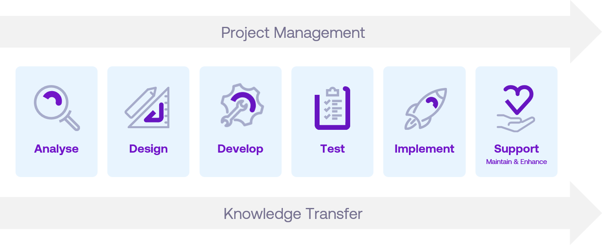

THE ANALYSE PHASE
During the Analysis Phase, Kerv will facilitate business and technical, functional and non-functional requirements understanding and documentation. Discovery of the existing environment will also be carried out in order to determine suitability for the planned deployment.

THE DESIGN PHASE
Detailed design documentation will be produced for all of the key areas of the solution. This includes individual settings and configurations required in order to meet the projects requirements and success criteria.

THE DEVELOP PHASE
The Develop phase of the project is the initial installation and configuration of the platform ready for testing and acceptance.

THE TEST PHASE
This is the most important phase of any project and typically the longest. It’s the first opportunity for the key stakeholders of the project to start interacting with the platform.

THE IMPLEMENT/MIGRATE PHASE
Kerv will work with the Customer to agree a suitable migration plan and ensure a smooth implementation and rollout of the platform.

SUPPORT, MAINTAIN & ENHANCE
Once the platform has gone live it is essential that it is maintained and enhanced throughout its lifecycle to ensure maximum return on investment. Kerv has a suite of support and managed services that can be tailored to our customer’s requirements.

Prerequisites
The following prerequisites will need to be met prior to the engagement starting:
[INSERT]

Assumptions
The following assumptions have been made ahead of this engagement:
[INSERT]

Out of Scope
The following items are deemed outside of the scope of this engagement:
[INSERT]

Acceptance of SOW
By signing this document the Customer agreed that the information detailed in this SOW document is accurate, understood and accepted. Any additional requirements or changes not listed within this document are to be agreed and may be subject to additional time and Charges.

SIGNED for and on behalf of Customer
Signature | Name | Position | Date

