Managed Support Services:Summary Framework Document

Introduction
  - This Service Framework document provides a comprehensive overview as to the Service definition and framework utilised by the Service Desk, in relation to Managed Support Services.
  - It outlines the specific Services and possible Service options that Kerv may provide, along with the associated service levels, service hours, and any applicable exclusions.
  - Any additional requirements or changes not listed within this document are to be agreed and may be subject to additional time and Charges.

Service Overview
  - Kerv offers the following Service options which may be delivered to the Customer where agreed on an Order form. The Service options may may be ordered and delivered individually or as a suite of Services to compliment each other and the overarching Managed Support Service.
  - The following Services together or individually shall be referred to within the Agreement as a “Service Option(s)” and will be delivered where set out and agreed within an Order form:
    - Managed Service Type
    - Managed Service Support Term (including FUP)
    - Managed Security
    - Site Audit/On Boarding
    - Patching
    - Back-Up Management
    - Endpoint Build & Logistics
    - Ongoing Endpoint Device Management
    - Virtual Machine Image Management
    - Disaster Recovery Management
    - Weekly Checks
    - Annual health Checks
    - Customer Managed Change Control
    - Hardware/Software Asset Management
    - Supplier/Vendor Management
    - On-Site Resource
    - Customer Success Management
    - Solution Architect as a Service
    - Annual Professional Service Days

Managed Service Support Term
  - The Initial Term for the Managed Support Services is set out in the Order. The Initial Term will commence from the Service Commencement Date for the individual Service.

Managed Security
  - A Kerv working with a Managed IT & Cyber Security Provider seeks to assist organisations embrace secure, cutting-edge Microsoft technologies, to help them transform and succeed whilst underpinning this Service with Kerv’s 24/7/365 Service Desk and Cyber Security Operations Centre (CSOC).
  - We offer a unique Service which may provide our customers enterprise-level IT services with the agility and personality of a closely trusted partner. Through our advanced technical capabilities, service excellence and exceptional people, we aim to build long-lasting partnerships that help our customers benefit from true IT transformation.
  - The Managed IT & Cyber Security Provider will facilitate action being taken, not only when a breach happens, but proactively; working to prevent a breach from with the key objective to reduce the risk to Kerv customers.
  - Our threat assessment will help deploy Microsoft’s industry leading security tooling combined with playbooks and automation to fortify our customers security defence. Where the option to build an internal 24/7/365 security operation isn’t viable due to the time, expense and technical expertise required, Managed Detection and Response (MDR) services represent an excellent potential solution for the customer to have a fully outsourced SOC that works in collaboration with us and/or their security team.
  - By leveraging CSOC services, our customer will experience & access the following benefits:
- Modern and proactive 24/7/365 threat analysis providing around the clock security protection.
- Access to qualified and experienced Security Analysts capable of identifying potential threats and unusual behaviours whilst quickly determining false positives.
- Efficient and bespoke automated playbook responses which seeks to dramatically reduce the time to detect, isolate and remediate threats.
- Proactive Cyber Threat Intelligence and Threat hunting activity allowing customer access to datasets around the world of known threats and cyber-criminal activity.
- Continuous security improvement from our expert team and security intelligence.
- Access to a security development team.

Site Audit / On Boarding (One Off Charge)
  - Site audit and on-boarding are important processes for Kerv to ensure that we have a comprehensive understanding of a Customer's environment, requirements, and expectations. These processes involve assessing our Customer's existing infrastructure, identifying any potential issues, and developing a plan to address them.
  - The key aspects of Kerv’s site audit and on-boarding process are:
- Discovery: The first step in the site audit and on-boarding process is to gather information about the Customer's environment. This includes understanding the Customer's business objectives, identifying the types of devices and systems in use, and documenting network configurations and software applications.
- Assessment: The next step is to assess the Customer's environment to identify any potential issues or risks. This includes analysing the network and system infrastructure for potential vulnerabilities, assessing security protocols, and reviewing disaster recovery and business continuity plans.
- Planning: Based on the results of the assessment, Kerv develops a plan for on-boarding the Customer. This includes identifying the resources needed, developing timelines, and outlining any necessary changes or upgrades to the Customer's environment.
- Implementation: Once the plan is developed and approved by the Parties, Kerv begins the on-boarding process. This may include deploying new hardware and software, configuring systems and networks, and testing the new environment to ensure it meets the Customer's requirements.
- Knowledge Transfer: As part of the on-boarding process, working with the Customer, Kerv collates information and documentation and maintains this within our internal knowledgebase. This ensures that we have familiarity with the new environment and understand how to support it to achieve the Customers business objectives.
  - By following a comprehensive site audit and on-boarding process, Kerv builds a baseline assisting our Customers transition to our Services. This approach seeks to help minimise disruptionCustomer.

Patching
  - Patching refers to the ongoing management, coordination and deployment of agreed software, operating system and security updates across in-scope Customer systems, where such Service has been agreed within an Order. The purpose of this Service is to assist the Customer in maintaining the security, stability and compliance posture of the Customer environment by ensuring that applicable patches are assessed, scheduled, deployed and reported on in line with agreed maintenance windows, change control requirements and any Customer-specific patching policy.
  - Where this Service is selected, Kerv will work with the Customer to define an appropriate patching approach, which may include patch cadence, deployment rings, maintenance windows, approval requirements, reporting requirements and agreed exclusions. Patching may include Microsoft operating system updates, security updates, critical updates and approved third-party application updates, subject to suitable tooling, packaging and deployment mechanisms being available and agreed between the Parties.
  - Kerv will apply a risk-based approach to patching, taking into account the severity of the update, business impact, system criticality, known vulnerabilities and any Customer-specific compliance obligations. Emergency or out-of-band patching may be considered where a critical security vulnerability presents a material risk to the Customer environment, subject always to agreed change control, service availability and any applicable Customer approval requirements.
  - Patching activity will typically include pre-deployment review, scheduling, deployment, monitoring of success and failure rates, remediation of failed deployments where reasonably practicable, and reporting of patch compliance. Where appropriate, deployment may be phased through test, pilot and production groups to reduce operational risk and support controlled release into the Customer environment.
  - The Customer remains responsible for confirming business application compatibility, providing suitable maintenance windows, ensuring systems are online and reachable, approving downtime-affecting changes, identifying excluded systems, and notifying Kerv of any business-critical periods where patching should not take place.
  - For the avoidance of doubt, major version upgrades, application regression testing, remediation of unsupported or End Of Life systems, firmware or BIOS updates, network appliance patching, project-based remediation activity, and any emergency security response outside the agreed Service Hours shall be considered out of scope unless separately agreed and contracted between the Parties.

Back-Up Management
  - Back-Up Management refers to the ongoing monitoring, administration, and support of backup services where such services have been agreed within an Order. The purpose of this Service is to assist the Customer in protecting agreed systems, data, and workloads by ensuring that backup jobs are configured, monitored, and reviewed in line with the Customer’s agreed backup policy, retention requirements, and recovery objectives.
  - As part of this service Kerv will be responsible for facilitating reasonable requests for the restoration of backups.

Endpoint Build & Logistics
  - Endpoint build and logistics refers to the process of configuring and deploying hardware and software to endpoint devices such as desktops, laptops, tablets, and smartphones. Where the on-boarding process is completed and this option selected, Kerv will look to understand the requirements of the customer to build a process that fits with the organisation at hand. This process may include:
- Planning: Before deploying any endpoint devices, Kerv is required to determine the hardware and software requirements of the organisation. This includes selecting the appropriate hardware devices, operating systems, productivity software, and security software.
- Procurement: Once the hardware and software requirements have been identified, Kerv will order the necessary equipment and software licenses.
- Configuration: After the hardware and software have been received, Kerv will arrange the configuration of the endpoint devices to meet the organisation's requirements. This includes installing the operating system and productivity software, applying security policies, and configuring network settings.
- Testing: Upon endpoint devices being configured, Kerv will seek to perform testing, ensuring they are functioning properly and are compatible with the organisation's infrastructure.
- Deployment: On completion of testing, the endpoint devices can be deployed to the end-users. This includes physically setting up the devices, installing any necessary peripherals, and verifying that the devices are working properly.
- Management: Upon deployment of the endpoint devices, Kerv will manage and maintain them. This includes applying security updates, software patches, and configuration changes, as well as monitoring the devices for performance issues or security incidents.
- Storage: Existing endpoints that are not currently in use (“stock”) will be returned to the customer and will remain on-site.

Ongoing Endpoint Device Management
  - Kerv utilises Microsoft Endpoint Management (formerly known as Microsoft Intune) which is a cloud-based device management solution. This is a comprehensive tool to manage endpoint devices and applications across a variety of platforms, including Windows, macOS, iOS, Android, and Linux.
  - Where agreed to be delivered, this will tool will be utilised by Kerv as part of a monthly Service and will perform:
- Assessment: Kerv will conduct an assessment of the Customer's current device inventory and management needs. This includes evaluating the Customer's existing device management solutions, security configurations, and user requirements.
- Planning: Based on the above assessment, Kerv will develop a device management plan tailored to the Customer's needs. This plan may include details on device inventory, software updates, security patches, backup and recovery procedures, and help desk support.
- Implementation: Kerv will configure the Microsoft Endpoint Management to manage the Customer's endpoint devices; including enrolling devices and configuring policies for security, applications, and updates (where appropriate).
- Monitoring: Kerv will continuously monitor the Customer's endpoint devices for performance, security, and compliance issues (using Microsoft Endpoint Management's monitoring and reporting tools). Kerv will be notified via alerts if associated issues arise and will take the appropriate action to address them.
- Maintenance: Kerv will perform routine maintenance tasks, such as software updates, security patches, and backup and recovery procedures, using the Microsoft Endpoint Management tool.
- Optimisation: Kerv seeks to work with the Customer to optimise their endpoint device management plan over time. This includes identifying areas for improvement and implementing changes to improve device performance, security, and user productivity using Microsoft Endpoint Management's analytics and insights tools.

Virtual Machine Image Management
  - Virtual machine image management is the process of creating, deploying, and maintaining software images for our customers virtual computer systems, such as Azure Virtual Desktop (AVD), Citrix Desktop as a Service (DaaS), and virtual servers. An image is a pre-configured snapshot of a computer system that includes the operating system, applications, settings, and other configurations that are required for a specific purpose or use case.
  - The following provides insight into the key aspects of image management:
- Image Creation: To create an image, the system administrator selects the hardware and software components that are required for a specific use case. Once established, they install the necessary operating system, applications, drivers, and configurations, and customise them according to the organisation's policies and requirements.
- Image Deployment: Once the image is created, it can be deployed to a single computer or multiple computers using various deployment methods such as disk imaging, network booting, or virtual machine cloning. This helps to automate the installation and configuration of software and settings across multiple devices.
- Image Maintenance: As software updates and new applications are released, the system administrator will be required to update the image, ensuring it remains up-to-date and secure and may be required to update the image to address any compatibility issues or security vulnerabilities that arise.
- Image Versioning: As images are updated, it's important to keep track of the different versions to ensure that the correct version is deployed to the correct hardware. This can be achieved by using version control systems or by assigning unique identifiers to each image.
- Image Testing: Prior to deploying an image, it's important to test it in a lab environment, to ensure that it works correctly and meets all the requirements. Testing can help to identify any compatibility issues, performance problems, or security vulnerabilities before they impact production systems.

Disaster Recovery Management
  - Kerv may provide ongoing support, coordination, and management of agreed disaster recovery arrangements, for the Customer systems and services. The purpose of this Service is to assist the Customer in maintaining an appropriate level of operational resilience by supporting recovery processes, validating recovery plans, and helping ensure that agreed technical recovery capabilities remain aligned to business requirements.
  - Disaster Recovery (DR) Functionality Testing Support: Kerv may support agreed technical checks to validate that disaster recovery functionality is operating as expected for in-scope systems. Full disaster recovery testing, including end-to-end test planning, coordination, execution, business validation, and post-test reporting, shall be scoped and contracted separately.
  - For the avoidance of doubt, this Service relates to the operational management and support of agreed backup and/or disaster recovery technologies. The development of
- wider business continuity strategies,
- full disaster recovery design,
- new DR platform implementation, or
- business-led continuity planning
shall be considered out of scope unless separately agreed and contracted between the Parties.

Weekly Checks
  - Kerv’s weekly checks refer to a set of routine tasks that we can perform on a weekly basis to ensure that our customers systems, Services, and infrastructure are operating smoothly, in compliance with industry standards and best practices. The specific checks performed may vary depending on the type of Service being provided. The following provides an overview of the common tasks that are typically carried out:
- System backups: Kerv regularly perform backups of the customer’s systems and data to mitigate data loss, enabling the customer to restore the system to its previous state.
- Performance monitoring: Kerv monitor the performance of systems and Services to identify any potential issues or bottlenecks. This includes monitoring resource utilisation, network traffic, or application performance.
- Infrastructure maintenance: Regular maintenance tasks are performed on the customer’s infrastructure, such as servers, network switches, and routers. This includes tasks such as firmware updates, hardware checks, and cleaning.

Annual Health check
  - A Kerv IT consultant will perform a health check ‘lite’ on the environment and make recommendations on best practices and enhancements; alongside security recommendations that may arise. Remediation of these issues will be carried out on a case-by-case basis depending on complexity, effort, and impact as to whether it will be managed through a separate project or included as part of the health check.

Customer Managed Change Control
  - Customer Managed Change Control is a process enabling customers to initiate and change controls to a Service that is being provided by a Kerv. The purpose of this process is to ensure any changes to the Service are properly evaluated, approved, and managed in a way that minimises disruption and maintains the customers objectives and timelines, while keeping open communication with Kerv.
  - The customer typically initiates the change control process by submitting a request for change (RFC) to Kerv. The RFC includes a description of the proposed change, the rationale for the change, the potential impact on the project or Service, and any associated risks and costs.
  - Kerv will evaluate the RFC and provide (where appropriate) a recommendation on whether the change is feasible, and if so, how it should be implemented. The customer is asked to review the recommendation and decide whether to approve or reject the proposed change.
  - Where the change is approved, the parties will collaborate to implement the change in a controlled and systematic manner. This includes defining the scope of the change, identifying any resources needed, developing a plan for implementing the change, and communicating the change to any affected stakeholders.
  - Throughout the change control process, the customer maintains overall responsibility for managing the change and ensuring that it aligns with their objectives and timelines. Kerv will support by providing expertise and support in evaluating and implementing the change.

Hardware/Software Asset Management
  - Hardware and software asset management is the process of tracking and managing an organisation's hardware and software assets, from acquisition to disposal. The primary goal of asset management is to ensure that an organisation's hardware and software assets are properly used, maintained, and accounted for, while minimising costs and risks.
  - Key aspects of this Service option are:
- Inventory Management: Creation of an inventory of all the assets that an organisation owns; including hardware assets such as computers, servers, printers, and networking devices, as well as software licenses, subscriptions, and usage.
- Procurement Management: Management of the procurement of new hardware and software assets; including purchasing hardware and software, negotiating contracts with vendors, and ensuring that all procurement processes are aligned with the organisation's policies and procedures.
- License Management: Managing software licenses involves ensuring the organisation is using licensed software, tracking license usage, and managing license renewals and upgrades.
- Maintenance Management: Managing the maintenance and repair of hardware assets, including performing routine maintenance tasks, managing warranties, and handling repairs and replacements as needed.
- Disposal Management: Upon the end of an asset's lifecycle, the proper disposal of the asset. This includes securely wiping data from hard drives and disposing of hardware in an environmentally responsible way.

Supplier/Vendor Management
  - This Service refers to the process of managing relationships with third-party suppliers or vendors who provide goods and services, for example where the Customer outsources management and responsibility of their third parties to Kerv. This is a critical aspect of ensuring that Kerv can deliver high-quality services to its customers while keeping costs under control.
- Relationship management: Kerv must maintain strong relationships with its suppliers and vendors to ensure that they are able to deliver high-quality services. This includes regular communication, collaboration on projects, and addressing any concerns or issues in a timely manner.
- Risk management: Kerv must identify and manage risks associated with its suppliers and vendors, including disruptions in supply chain, data breaches, or regulatory compliance issues. This may involve implementing strategies to mitigate these risks or identifying alternative suppliers or vendors to work with.

On-Site Resource
  - Kerv may provide on-site resource to perform IT support services, as further set out below:
- Role: The role of the on-site resource is to provide IT support services to the customer. This may include troubleshooting technical issues, performing routine maintenance tasks, and providing end-user support.
- Expertise: On-site resources are typically subject matter experts in their field, with an understanding of the customer's IT environment and systems. They are usually able to quickly identify and resolve technical issues, and provide guidance on best practices and industry trends.
- Communication: Effective communication is demonstrated, to enable the communication of technical issues and solutions in a clear and concise manner, building a strong relationship with the customer's team.
- Availability: On-site resources are typically available during regular business hours, although they may be available for after-hours support as needed.
- Accountability: Accountable for the Services they provide, subject to an agreed service level agreement (SLA) established with the customer. This includes meeting performance metrics, responding to service requests within specified timeframes, and maintaining documentation of all work performed.

Customer Success Management
  - Customer Success Management (CSM) is a service that focuses on ensuring that our customers achieve their desired outcomes when using our Services. The goal of CSM is to maximise customer satisfaction and retention, and to drive long-term business value for our customers.
  - The below provides insight into a few of the key aspects of Customer Success Management:
- Understanding the Customer's Goals: The CSM team works closely with customers to understand their business goals, needs, and challenges. They collaborate with customers to assist in defining success metrics and identification of key performance indicators (KPIs), which are proposed to be used as a measure of the success of the Service.
- Onboarding and Training: CSM teams are responsible for ensuring that customers are properly onboarded and trained on how to use the Service. They provide resources and guidance to assist customers in achieving the most benefit (as reasonably possible) from their investment.
- Relationship Management: CSM teams build strong relationships with customers and act as their advocates within Kerv. They provide ongoing support and act as a point of contact for any questions or issues that may arise.
- Proactive Engagement: CSM teams proactively engage with customers to identify potential issues before they become major problems. They offer suggestions on how to optimise product usage and share best practices which may help customers achieve their desired outcomes.
- Customer Feedback: CSM teams gather feedback from customers on their experiences with the Service. They use this feedback to drive product improvements and to facilitate Kerv in meeting customer needs.

Solution Architect as a Service (SAaaS)
  - "Solution Architecture as a Service" (SAaaS) is a concept that extends the idea of "as a service" (aaS) models to the field of solution architecture. In the context of information technology and business, "as a service" typically refers to the delivery of a particular service over the internet, often on a subscription basis.
  - Kerv’s Solution Architecture as a Service, provides solution architecture expertise and services on-demand, including the following:
- On-Demand Expertise: Organisations can leverage SAaaS to access solution architecture expertise as needed, without the need to hire a full-time solution architect. This can be particularly useful for smaller companies or those with intermittent needs for architectural guidance.
- Scalability: SAaaS can scale with the needs of the organisation. Whether a company is working on a small project or a large-scale transformation, the level of solution architecture may support accordingly.
- Cost-Effective: Instead of a dedicated in-house solution architecture team, organisations can opt for SAaaS to manage costs more effectively. The customer would pay for the architecture services used, avoiding the need for a constant investment in personnel.
- Flexibility: SAaaS provides flexibility in the types of services that can be accessed. For example, this might include architectural reviews, design consultations, technology selection advice, and more.
- Knowledge Transfer: Kerv, as a SAaaS provider, may also contribute to knowledge transfer through sharing best practices, frameworks, and methodologies with the in-house teams. This can enhance the capabilities of the internal teams over time.
- Rapid Deployment: SAaaS can offer rapid deployment of architecture services, allowing organisations to get timely and expert input on their projects without delays associated with hiring and onboarding.
- Continuous Improvement: SAaaS providers can assist in continuous improvement by staying updated on the latest industry trends, emerging technologies, and best practices. This ensures that the architectural guidance provided is aligned with the current state of the industry.

Annual Professional Services Day Entitlement
  - An annual entitlement to a pre-determined number of days of Professional Services for the Customer’s use, over the course of a year.
  - The bank of days approach allows a customer to purchase a set number of Professional Service days upfront, which can be utilised throughout the year; a flexible and cost-effective way to access the Services.
  - The Professional Srvices that are enabled to be delivered, may vary depending on the customer's needs. Examples of services that may be covered include consulting, project management, training, support, and implementation services.

Support Services Schedule

Incident Response Times (“SLA”)
  - The following provides the standard Service levels to be applied to a customer Order, unless other SLAs have been agreed in writing between the parties:
Incident Response Times
Priority Code | Description | Target Response time | Target Resolution Time | Incident Logging Method
P1 | Critical | Within 30 minutes | Within 2 hours | Telephone Only
P2 | High | Within 2 hours | Within 4 hours | Telephone  Web Incident Portal  Email
P3 | Medium | Within 4 hours | Within 8 hours | Telephone  Web Incident Portal  Email
P4 | Low | Within 1 business day | Within 5 business days | Web Incident Portal  Email
P5 | Planned / Request | Within 2 business days | Planned as agreed | Web Incident Portal  Email
  - The below priority levels will be applied to an Incident and/or a Request in accordance with this Agreement:
Incident Prioritisation Levels
Priority | Description
1 | Incident  - Widespread incident requiring immediate attention, affecting multiple end users who are unable to work due to complete loss of Service, or an incident which is severely impacting a stores ability to transact business.  Request  - Emergency Infrastructure change  - Emergency End User account or service change
2 | Incident  - Localised incident affecting multiple end users, unable to work to full capacity due to loss of an element of Service.  - Designated VIP user unable to work  - Reduced functionality or performance causing disruption to the completion of business-critical tasks  Request  - Non-emergency infrastructure change  - Non-emergency End User account or service change
3 | Incident  - Single End User unable to work due to loss of Service or Services  - Reduced functionality causing some disruption to the completion of business-critical tasks  Request  - Low priority infrastructure change  - Low priority End User account or service change
4 | Incident  - A low impact incident that has been agreed with, or stipulated by, the customer not be resolved or worked on until a specific time or date.  Request  - A request for device - Installation, Move, Addition or Change  - A request for Professional Services such as consultancy or other ad-hoc chargeable services.
5 | - Non-urgent, Incident, Query or Request

Contact Methods & Incident Management
Organisational Structure
  - Kerv provides a Customer support function for the purpose of handling calls, portal tickets and emails in relation to Incidents, Requests and Changes.
  - The support function operates out of two sites providing resilience and comprises of a Service Desk, Senior and Principal Engineering resources, supported by a Service Desk Manager.
  - Alongside the core support function sits; change management, problem management and transition management functions.
Raising a Support Ticket / Incident
  - The table below outlines the three methods of contacting the support team. Please note P1 Incidents should be logged via a telephone call at all times. Failing to do so can result in a breach of the agreed Service level.
Contact Method | Contact Details
Telephone | 03330 033305
Email | support@kerv.com
Portal | https://support.kerv.com
Ticket Acknowledgement
  - Once a ticket has been logged, an email is sent to the recipient detailing the ticket reference number and the assigned priority. This reference number will need to be used for any escalations.
Responsibilities
Function | Responsibility
Service Desk Engineers | The Service Desk is our central point of contact and a focal point for all Requests, Incidents and alerts that come into the support function. The team is responsible for the initial investigation and first fix resolution where possible. The Service Desk will attempt to resolve and close support tickets without having to escalate onto the other functions.
Senior Engineers | The Senior Engineers receive Incidents or Requests that have been escalated by the Service Desk. This group of engineers is the interface between the Service Desk and Principal Engineering support. Engineers working in this team have a broad knowledge of Kerv’s product portfolio.
Principal Engineers | The technology specialists are an escalation for the Senior Engineers. These teams are responsible for the ongoing proactive management of the technical platforms.
Change Management | Change Management is responsible for managing the strict processes that govern the Change Advisory Board (CAB). The CAB ensures that changes written by our Change Engineers are technically approved by senior Customer or Platform engineers and authorised by customers, minimising risk, and maintaining compliance.
Service Transition | The Service Transition function is responsible for ensuring new Services move smoothly from project into Service, facilitating Kerv meeting customer expectations, whilst operating in a way that is consistent with existing service architecture.

Incident Management Process
  - The process followed as a result of an unplanned interruption to Service or a reduction in the quality of Service provided is set out below:
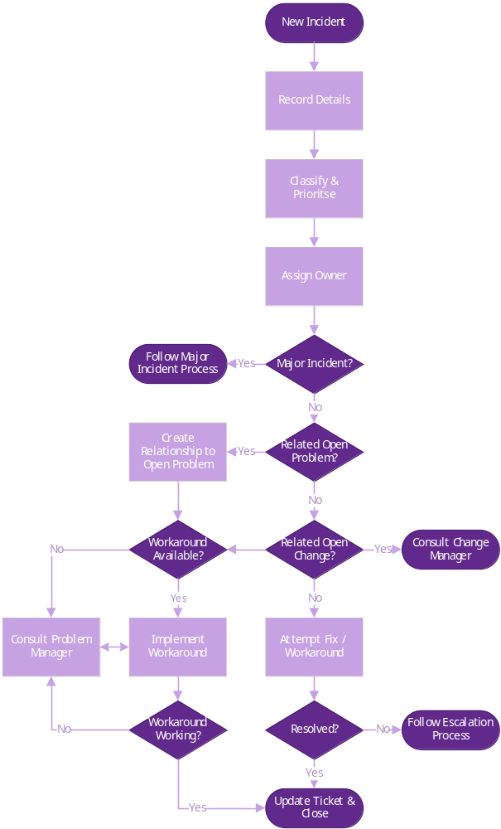

Major Incident Process
  - The process followed as a result of an unplanned interruption to Service, where such meets the criteria of a Major Incident, is set out below:
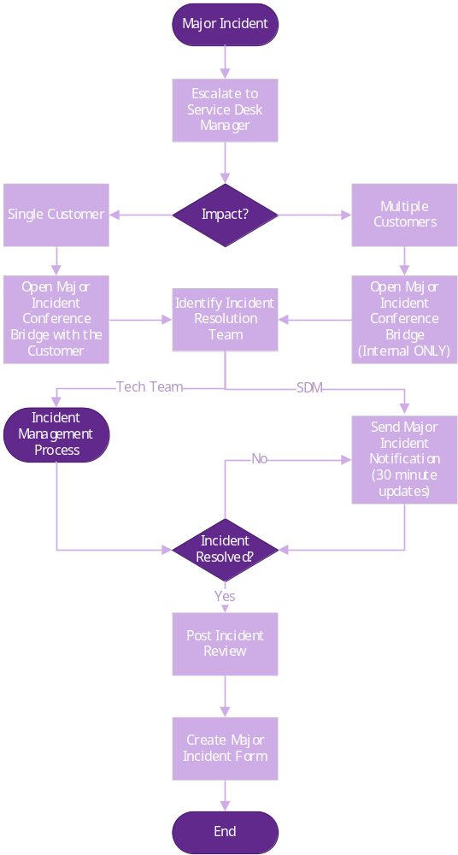

Escalation
  - Customers can initiate an escalation once they have followed the standard support process. If at this time, the customer is not satisfied with the level or timeliness of support received, then they may escalate.
  - An escalation should be initiated by a customer or any Kerv staff member if they believe there is tangible impact to any production environment, or there is high risk to the business operations.
Incidents/Support
1st Escalation (SDM) | Dave Colam | 07525 987082 | dave.colam@kerv.com
2nd Escalation (Ops Dir) | Paul Coyle | 07539 036324 | paul.coyle@kerv.com
3rd Escalation (Managing Director) | Jane Hamlyn | 07961 323236 | Jane.hamlyn@kerv.com

Kerv Problem Management
  - Problem Management is an ‘IT service management’ (ITSM) process that focuses on identifying, analysing, and resolving the root causes of recurring or chronic issues within an organisation's IT infrastructure or services. It is a proactive approach aimed at preventing future incidents and minimising the impact of known problems on the business.
  - The primary objectives of the Kerv Problem Management offering include:
- Root Cause Analysis: Identifying the underlying causes of Incidents or problems to prevent their recurrence.
- Documentation: Keeping records of known errors, workarounds, and resolutions to aid in problem-solving and future reference.
- Prioritisation: Assessing the impact and urgency of problems to allocate resources effectively.
- Problem Resolution: Implementing permanent fixes and solutions to eliminate recurring issues.
- Knowledge Transfer: Sharing insights and information with relevant teams to improve overall IT service quality.
- Continuous Improvement: Leveraging lessons learned from problem resolution to enhance overall IT operations.
  - Problem Management works in tandem with Incident management seeking to ensure IT Incidents are addressed promptly while also seeking to address the root causes to prevent future Incidents from occurring.
Problem Management Flow
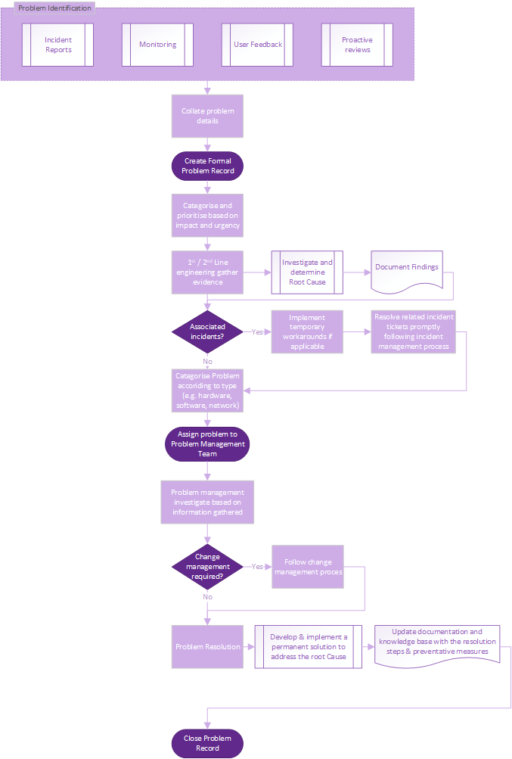

Kerv Change Management
  - For changes to be made to the Customer’s environment where such are initiated by Kerv , a formal change control process is required.
Kerv CAB Schedule
  - Changes to customer environments must be approved by the Customer’s team, prior to submission to the Kerv CAB.Demonstration of the approvalmay either be in the form of i) the Customer’s own change control process, or ii) via an email from an agreedCustomer contact(s). All Kerv change requests will need to be reviewed and approved by Kerv CAB.
  - Kerv CAB works on an agile basis, whereby change requests are submitted to the CAB for review at any time during the working week. These are then reviewed by the CAB and approved if they meet the relevant criteria, as further described in the section below titled “Identify Changes”.
  - Customers are responsible for notifying Kerv of any changes they plan to make to their production environment that may have an impact on the infrastructure and/or services Kerv maintain for the Customer, open dialogue is key for risk mitigation and service up time.
Emergency CAB
  - The change procedure supports Emergency (E-CAB) change, where required to be utilised. This Service should not be considered for use unless there is deemed a major impact to the operational stability of the Customer, wherever possible and/or practical the standard change process should be followed.
Change Authority Process
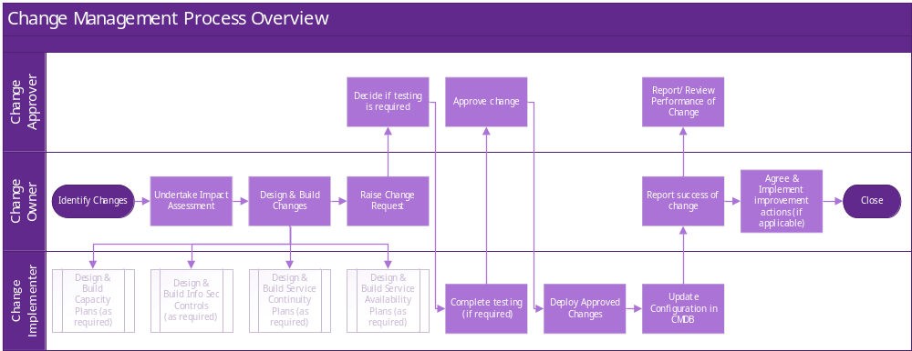
Identify Changes
  - Any new or changed services, products or data sets are subject to the change management process.
Undertake an Impact Assessment (IA)
- The IA is undertaken to identify: The benefits / costs of the change.
- The assets affected by the change.
- Any associated risks to the business.
  - Several Projects, IT service delivery and support teams need to be consulted to ensure the accuracy of the assessment.
  - The ‘Asset and Configuration Management’ database should also be consulted as appropriate.
Design and Build Changes
  - All Changes are subsequently designed and written, in accordance with the appropriate policies and processes.
  - Included within the change, service delivery capacity plans, information security controls, availability and continuity strategies and contingency plans are all reviewed and revised as necessary.
  - Plans to roll back or remedy any problematic changes are documented at this stage.
Raise Change Request
  - Once the service, product or data set has been formally built and tested, the Request for Change should be formally raised by the customer.
  - When submitting a change request in to the Kerv CAB, the following details must be included:
- Change Title: High level overview of the change and the associated ticket number
- Description of the change: Brief description of the change
- Overview of the change: steps involved in the change (if no associated support ticket)
- What it hopes to achieve: the aim of the change post deployment
- Who it is for: The name of the Customer
- Estimate down/completion time: the amount of time Kerv will need for the change window.
  - Further details of the individual steps for the change will be included in the Support Ticket these will include:
- Prep: What needs to be carried out before the commencement of the change, either by the Customer or Kerv (e.g., pre-change backups)
- Implementation: Detail the actions that will be performed, step by step.
- Testing: Steps needed to be taken to ensure the change has been successful.
- Rollback: Considered steps on what needs to be done to be able to roll back the change, so that the environment is returned to a state prior to the beginning of the change implementation.
Approve Change Request
  - Change Requests (where approved) assist with ensuring availability of resources, as necessary by the change approver.
Revise Change Schedule
  - The change schedule is updated to reflect the ‘approval’ status of the Change Request, an agreed release date will be discussed and shared with the relevant parties.
Release and Deploy Approved Changes
  - All changes are released and deployed into the live environment in accordance with the following ‘Release Process’:
    - Supporting information security controls, capacity, availability, and continuity plans / actions are issued and implemented (if appropriate/ applicable).
    - The Asset and Configuration Management DB is updated to reflect new / changed assets and configuration assets.
    - Following the release of each change an update stating ‘success’ or ‘failure’ of the release, any arising issues and actions resulting from the release will be reported to the customer.
    - The change log is updated to confirm the Change Request is complete and adjusted as necessary to reflect status.
  - If a change is unsuccessful, the agreed planned roll back/remedy actions will be implemented, and the root cause of the failure investigated. Details of any roll back/remedial activities are documented and shared with the customer.
Report Performance of Change Management
  - The Change management process and recent reports for the key performance measures are analysed (if required) during regular management meetings.
  - The ‘Change Management process’ performance will be reviewed on an annual basis, subject to such being otherwise agreed and contracted.
  - Corrective/preventive and improvement recommendations will be duly considered and carried out where reasonably necessary and appropriate, always subject to the agreed contracted terms.
Agree and Implement actions
  - As a result of each change or performance review:
- corrective, preventive and improvement actions will be agreed as appropriate,
- completion dates for any of the above points actions will be agreed and completion actions monitored,
- where appropriate corrective, preventive & improvement action(s) are verified to ensure they are complete and effective (where reasonable and applicable).
  - The change procedure supports Emergency (E-CAB) change. This facility should not be considered for use unless there is deemed a major impact to the operational stability of the Customer. wherever possible and practical the standard change process should be followed.

Non-Service Agreement Items
  - The following will all be deemed out of scope of the Managed Support Services, unless otherwise has been fully agreed and contracted between the parties:
  - Subject to paragraph 6.1 above, the ’out of scope’ items will include (but not be limited to) the following:
- Project-based work: Any work that is not part of the ongoing management and maintenance of the Customer's IT infrastructure is typically considered out of scope. For example, implementing new software or hardware, or deploying new systems where such has not been procured via an Order.
- Non-standard or legacy systems: Systems that are not part of the standard IT infrastructure or are no longer supported by the vendor may be considered out of scope.
- Third-party vendor management: Any management of third-party vendors or their services, such as software vendors, hardware vendors, or other service providers, may be considered out of scope.
- Business analysis and strategy: Services that involve assessing and improving the Customer's business processes or developing strategic plans may be considered out of scope.
- Training and user support: Providing training or end-user support services may be considered out of scope, as they are typically not part of the core managed services offering.
- Capital expenditures: Any costs associated with the purchase or upgrade of hardware or software that are not part of the standard managed services agreement may be considered out of scope.
- Business continuity and disaster recovery planning: Services related to developing and implementing business continuity and disaster recovery plans may be considered out of scope.
- Physical infrastructure: Services related to the management of the Customer's physical infrastructure, such as cabling or power management.
- Compliance and regulatory services: Services related to compliance and regulatory requirements, such as (but not limited to) HIPAA or PCI-DSS, or any other requirements which need specialised knowledge and expertise.
- Software development: Developing custom software or applications may be considered out of scope, as it is typically a separate service offering that requires specialised skills and resources.
- Mergers and acquisitions: IT Services related to mergers and acquisitions, such as due diligence or integration planning, are required to be discussed and contracted separately.
- Strategic consulting: Services that involve providing strategic advice or guidance to the Customer's management team may be considered out of scope.
- Physical security: Services related to the management of the Customer's physical security, such as access control or surveillance.

